**Grace Nardei**

Six specific data driven facts

300-600 word story

Dataset with at least 6 columns

10 records 11 rows at least counting header

Dataset – google sheet

Put link at bottom of story

I explored the amount of money that women earn weekly, sorting the data of earnings by age group and the year the earnings were reported. Link to created spreadsheet:

[Median weekly earnings for women in the united states by year - Google Sheets](https://docs.google.com/spreadsheets/d/1gFImaAKUsLMVXbdP8VronE7ote7YQph6ftRVdLDUSwo/edit#gid=0)

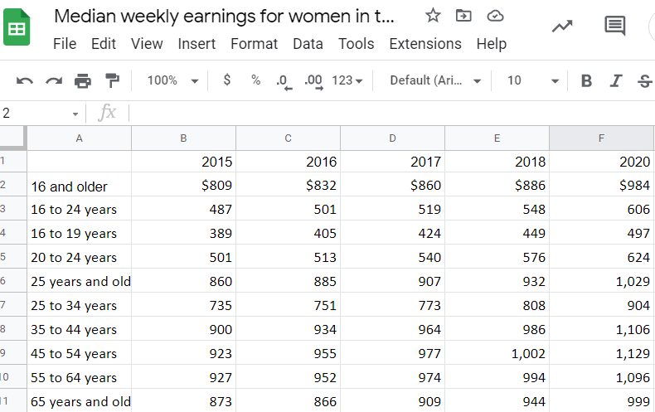

The data was taken from the bureau of labor statistics

[Earnings (CPS) (bls.gov)](https://www.bls.gov/cps/earnings.htm#demographics)

There were some interesting findings that I found from the data. Though the project required 6 columns, the website did not have data for the year of 2019.

Wages have increased for women overall over the course of five years from 2015 to 2020. Though inflation is a likely contributor, it would also be nice to think that women are earning more. The data point on women aged 35 to 44 and 45 to 54 seems to suggest that women seem to be making more when setting inflation aside. The $200 difference seems to suggest that women who are experienced and well into their careers are progressively earning more. It would suggest that women of today can look forward getting paid more for their work than their predecessors (even when you take inflation into account.)

Wages also decrease as women approach the age of retirement. They also decrease thereafter. This was consistent for men too. Work productivity and effort can decrease with age, especially when one is nearing retirement. This could likely contribute to why wages decrease as one ages. Companies may also be looking to invest in the future workforce as well, thus experience is valuable only up to a point.

There was also some interesting information I gleaned when I glanced at men’s earnings and compared them to women’s earnings. (Besides the fact that men earn more than women.)

Another interesting thing I found is that when men reach the age group of 55 to 64, their wages actually increase whereas with women their wages decrease. There is a down ward slope of earning for both saxes once they reach the later years, but that one specific data point seems to suggest that men reach a certain age point, their wages increase and when women’s reach that same age point, their wages decrease. I wonder at what is the cause of this. I can only postulate and consider various things, such as America’s lack of paid leave system, biases etc, but it is clearly a complex issue.